Conquering Resistance
November 11, 2017
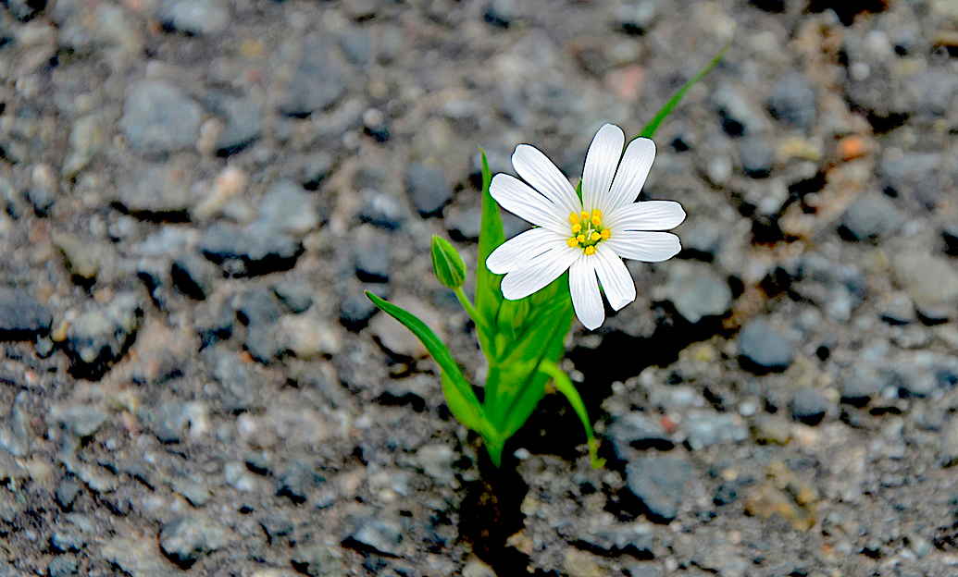
Lord, please help us to understand that there is resistance in everything worth doing and You are always living and moving and having Your very being in our hearts. You can and will help us, if we ask. Amen

Well, I want to start this off by saying, I didn't know what to say to the Lord. I haven’t honored my husband the way I should. I do get irritated when it is not convenient, but then I remind myself how happy I am to have him with me and I correct myself.

I don’t like my fleshly reactions, Jesus. And I know you don’t. You gave me the card, “Respect for him is respect for Me.” I just get tired and weary trying to meet everyone’s needs and still take care of the Channel. I am so, so sorry for my sometimes lousy attitude.

Jesus answered me, “I’m so glad you see that and are repenting. What a great treasure he is for you, Clare. Someone to be greatly honored and loved to your utmost capacity. Not many have the kind of relationship you have together with him.

"Yet, I do understand your fatigue. But I ask you: why are you so slow to call on My help and expect it? Have I not told you, that as you pour yourself out more and more for others, you will have more and more strength from Me?"

Lord, I forget!

"And you have those who help you to forget and suggest that you should instead be irritated and disrespectful…not so it shows on the outside, but deep down inside where it poisons your heart and drains your energy. I am so glad you are addressing this grievous fault, My Daughter. Show your love for Me through him, and be a joyful giver."

Can You please make me stronger, Lord?

"I can. I will—but there are times when you must stretch yourself, because I prefer to see you giving until it hurts. Because you would hurt very much if you didn’t have him here to give to. And it is so good for you to be stretched and grow in character and charity.

"Love is not just a thought, a feeling, or spoken word; love is a commitment to do what is inconvenient in such a way that it appears to be the most natural and easiest thing in the world for you. In fact, it brings your heart joy instead of resentment—which steals your energy and sets you up for a fall. Many times I have seen you that way, but it is more of a trial when you feel you’ve blown it and you are under correction, as you are feeling now.

"Knowing that you have failed in some way is never easy. This is the test of a man or woman’s nature: how do they interact with difficult and fatiguing circumstances when they know they are under correction? You see, this is good for you, very good for you, because it is causing you to pour more of yourself out selflessly on behalf of another.

"Poor Clare, what you are really struggling with is your inadequacies and failures in good judgement and this is always hard, Beloved. Nonetheless, I love the way you press in with not a thought of leaving the race. I really do."

“Thank You, Lord, but we both know it is all Your fault!“ I said with a smile.

He continued, "I want you to share with our Heartdwellers your feelings of inadequacy."

Well, my dear friends, it seems like I make two steps forward and one step backward. Is that right? Yeah, kind of... I am making progress with the keyboard and flute, but for some reason I cannot fathom, I forget to do my vocal exercises during the day… Then a day turns into 3 days, etc. Then Friday and Saturday roll around and before I know it, my next lesson comes up and I haven’t worked as hard as I should have.

I have never been used to singing around the house. I’ve always been very quiet and easily get lost in what I am doing.

Lately, though, I am doing well with the flute and keyboard, I am just way behind on vocal exercises. As a result my voice is not opening up the way it should.

Tonight, at the communion service, I begged the Lord to help me really press in. Because I have many songs I want to sing. When I think of them, I feel very defeated, because you should have heard them months ago. This latest mess-up over the radio certainly didn’t help matters at all. So, I am feeling badly enough to cry, and cry out for help. In fact, I am putting myself on the prayer warriors list!

Is that what you wanted me to share, Lord?

Jesus began again, “It is, because you are not alone. Because many scores and scores of Heartdwellers are going through the very same sadness. They have the gifts, but practicing them goes through elusive periods that are very disheartening. I wish I had a quick and easy answer, but I don’t. All I can tell you, My very dearest ones, is that breakthrough is coming, deliverance is coming, and until then I need you to carry this cross with resolve and dignity. Knowing that this will not last forever, there is an end in sight.

"Many of you are learning how vulnerable you are to distractions and that you MUST apply more discipline and control to your environment. You must discern between the worthy and the vain and useless things.

"To master your skills and what you feel called to do, you will need to make more and more sacrifices, until you have excluded every occasion of wasting time and you truly feel good about your progress.

"Some of you have jobs and children and responsibilities that demand a certain amount of time. I do not expect the impossible. What I do expect is slow, steady progress— pressing in, no matter how slowly you perceive yourself going. For those who do not give up, breakthrough will come and the greater the struggle you had, the greater the breakthrough you will have.

"Often times I allow these long, hard journeys to harden you off so your roots will go deep and the heat of life will not dry out the superficial roots. No one can come along and uncover your roots and see them lying just beneath the surface, where they can be easily destroyed by the heat of the day. No, you were wise, you faced the resistance in the hard soil or pavement and penetrated down until you hit good earth.

"This is what it takes to succeed. Roots must go deep and find the moist soil where they can send out shoots to stabilize the plant and be nourished. Imagine what resistance that seed must have weathered before it could flower. And so it is with you, My Brides, many of you have had breakthroughs in one area, only to find that you are still lagging behind in others. Do not give up the fight. Press in, do not withdraw from the battle.

"And you, My Clare, must do the same, knowing that I am faithful and will not deny you the help you need. I am here to help and the more you rely on Me, the less resistance you will have.

"I will, however, put you in a position where you must decide what is most important to you. And by this you will either stand or fall. Choose only the better part. Choose only the skill sets I am cultivating in you. Choose only to honor your husband and be faithful to your state in life, as well as the Channel and the dear souls who love and pray for you.

"How fortunate you are to have such as these as your companions in this life! This, too, is a rare gift. These souls are on the same journey, filled with the same love for one another that I have for them. Be grateful for these trials and come to Me when it seems to be just too much. I will refresh your soul. I will restore you, and I will help you conquer this resistance."

